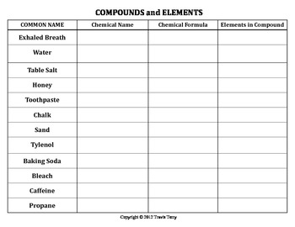
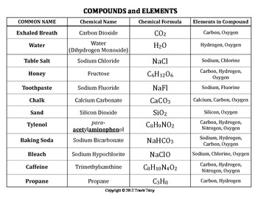

Modelling Chemical Compounds
Common Name | Chemical Name | Chemical Formula | Elements in compound | Drawing
Exhaled breath | Carbon Dioxide | CO₂ | 1 carbon  2 oxygen
Water
Table Salt
Honey
Toothpaste
Chalk
Sand
Panadol
Baking Soda
Bleach
Caffeine
Vinegar
Sugar

Chemical Name | Chemical Formula | Elements in compound
Carbon Dioxide | CO₂ | 1 carbon  2 oxygen
Sulfuric Acid
Hydrochloric Acid
Ammonia

